**COMET BAY COLLEGE**

**Physics - Unit 2 - Task 1**

**Laboratory Test**

**Name: Total Marks /35**

**20 minutes Reading and Writing time.**

**15 minutes to Setup and Collect Data from the Experiment**

**20 minutes to Finish the Report**

**Important:**

It is advisable that the Aim, Hypothesis, Prediction, Materials list and Method, plus an Idea on how to record your results be completed before starting your experiments. Also it is recommended that you read all the material on this sheet before beginning.

**Background**

Light slows down when passing through different transparent materials. The more it slows down, the more it bends when it hits a **medium** made of that material. **Snell’s Law of Refract ion** shows the relationship between incidence and refraction angles and the **phase** velocities of the materials involved.

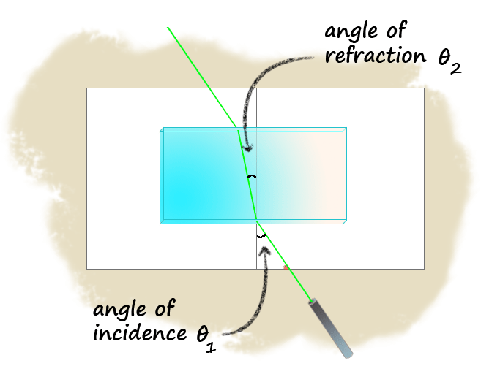***Figure 1***

$\frac{sin θ_{i}}{sin θ_{r}}$**= $\frac{v_{i}}{v_{r}}$ = $\frac{λ_{i}}{λ_{r}}$ = $\frac{n_{r}}{n_{i}}$**

**c = λ f**

where: i is the incidence

r is the reflection

c is the speed of light in metres per second (ms-1)

λ is the wavelength in metres (m)

f is the frequency (Hz)

n is the relative refractive index

v is the velocity in metres per second (ms-1)

**Aim**

How does the speed of light change (noted by the amount of diffraction) when traveling through different media?

**Apparatus (per group)**

|  |  |
| --- | --- |
| * Sheets of grid paper * Protractor * Ruler * Light Box | * Petri dish filled with Gelatine * Petri dish filled with Water * Petri dish filled with Glycerol * Power Pack |

**Pre-Lab**

* Many materials have a well-characterised refractive index.
* Water is known to have a refractive index of 1.333, whereas Glycerol and Gelatine have refractive indices of 1.473 and 1.21, respectively. While air has a refractive index of 1.00277.
* The speed of light remains constant, but constant relative to the material it is passing through. In a vacuum this is 2.99792458 × 108 m s-1.
* The densities of Water, Glycerol and Gelatine are, 1.00 × 103 kg/m3, 1.26 × 103 kg/m3, 0.98 × 103 kg/m3, respectively
* **15 minutes to Setup and Run the Experiment**

**Post-Lab Discussion must include the following**

* What have you found out about the experiment? Consider your aim and hypothesis.
* What could be discussed in regards to the accuracy of the results and the apparatus’s accuracy.
* Compare the speed of light found in the experiment for the different materials with the speed of light that could be calculated using the refractive indices. This is the error analysis.
* Explain how you could use your results in real life cases.
* Use the practical results to discuss how speed of light varies with different materials. You can choose to order them however you choose; i.e. refractive index, density, etc.

**Conclusion**

Write a conclusion for your lab. You should refer to your original hypothesis, and to the dependent and independent variables.

**Marks Distribution**

|  |  |  |  |  |  |
| --- | --- | --- | --- | --- | --- |
| Section | Marks Available | Marks Received | Section | Marks Available | Marks Received |
| Aim | n/a |  | Method Figure | 2 |  |
| Hypothesis | 4 |  | Results (exc Graph) | 5 |  |
| Prediction | 1 |  | Graph | 5 |  |
| Parameters | 3 |  | Discussion | 10 |  |
| Materials list | n/a |  | Conclusion | 5 |  |

**Aim:**

How does light refract differently when traveling through different media?

________________________________________________________________________________________________________________________________________________________________________________________________________________________________________________________________________________________________________________________________________________________________________________________________________________________________________________________________________________________________________________________________________________________________________________________________________________________________________________________________________________________________________________________________________________________________________________________________________________________________________________________________________________________________________________________________________________________________________________________________________________________________________________________________________

**Apparatus (per group)**

|  |  |
| --- | --- |
| * Sheets of grid paper * Protractor * Ruler * Light Box * Power Pack | * Rectangular transparent material * Petri dish filled with Gelatine * Petri dish filled with Water * Petri dish filled with Glycerol |

**Method**

1. Using the results sheet, place it flat in front of the light box.
2. Adjust the light in the light box until the sides of the light beam exit parallel.
3. Place the single slit cover over the light source.
4. Place one of the test materials on the sheet of paper, positioned in the circle.
5. Line up the light ray so it enters the petri dish at 20o, 35o and 50o to the normal.
6. Trace the outline of the beam of light onto the paper, starting from the light source and indicating the point where it enters and exits the petri dish. (Note: The entry point should be constant)
7. Measure the angle of incidence with the angle of reflection (see Figure 1).
8. Repeat for other test materials

Figure 1: Laboratory equipment set up

**Results**

Refractive index of air is 1.00277

Speed of light in air is calculated to be vair = = 2.98964 x 108 m s-1.

|  |  |  |  |  |  |  |  |  |
| --- | --- | --- | --- | --- | --- | --- | --- | --- |
| Material | Practical **θi** | Practical **θr** | vair | Calculated vmaterial from practical | Refractive Index of Material | $$\frac{n_{material}}{n_{air}}$$ | Calculated vmaterial using refractive indices | $\frac{Practical v}{Theoretical v}$ × 100 |
| Water |  |  |  |  | **_** | **_** | **_** | **_** |
| Water |  |  |  |  | **_** | **_** | **_** | **_** |
| Water |  |  |  |  | **_** | **_** | **_** | **_** |
| Average | **_** | **_** | **_** |  |  |  |  |  |

|  |  |  |  |  |  |  |  |  |
| --- | --- | --- | --- | --- | --- | --- | --- | --- |
| Material | Practical **θi** | Practical **θr** | vair | Calculated vmaterial from practical | Refractive Index of Material | $$\frac{n_{material}}{n_{air}}$$ | Calculated vmaterial using refractive indices | $\frac{Practical v}{Theoretical v}$ × 100 |
| Gelatine |  |  |  |  | **_** | **_** | **_** | **_** |
| Gelatine |  |  |  |  | **_** | **_** | **_** | **_** |
| Gelatine |  |  |  |  | **_** | **_** | **_** | **_** |
| Average | **_** | **_** | **_** |  |  |  |  |  |

|  |  |  |  |  |  |  |  |  |
| --- | --- | --- | --- | --- | --- | --- | --- | --- |
| Material | Practical **θi** | Practical **θr** | vair | Calculated vmaterial from practical | Refractive Index of Material | $$\frac{n_{material}}{n_{air}}$$ | Calculated vmaterial using refractive indices | $\frac{Practical v}{Theoretical v}$ × 100 |
| Glycerol |  |  |  |  | **_** | **_** | **_** | **_** |
| Glycerol |  |  |  |  | **_** | **_** | **_** | **_** |
| Glycerol |  |  |  |  | **_** | **_** | **_** | **_** |
| Average | **_** | **_** | **_** |  |  |  |  |  |

**Results (this can be taken to the bench)**

Position front of Light Box somewhere in this region. Ensure the light beam intersects where the “Centre Line” meets the “Normal Line”.

Centre Line

Normal Line